Movie Review Application
  - Technical Design Document
  - Version: 1.0

1. Document Overview
This document details the technical design for the Movie Review Platform. The application is a RESTful web service enabling users to search movies, read & submit reviews and view top-rated movies based on specific genre. This RESTful web service also enables administrative functions for managing the movie catalog.
1.1 Goals
- Provide a public API to search movies by title or genre.
- Allow users to rate movies and submit textual reviews.
- Automatically calculate and display a movie's average rating.
- Provide administrative APIs for full CRUD operations on the movie catalog.
- Support bulk operations for efficient data ingestion.
1.2 Technology Stack
Component | Technology & Version
Backend | Java 21, Spring Boot 3.2.3
Database | MySQL 9.5.0
ORM | Hibernate / Jakarta Persistence
Build Tool | Maven
API Format | JSON over HTTP/REST

2. System Architecture
The application follows a standard, layered monolithic architecture, separating concerns into Controller, Service, and Repository layers. This promotes maintainability, testability, and clear separation of responsibilities.
2.1 High-Level Architecture Diagram
The following diagram illustrates the layered architecture and data flow:
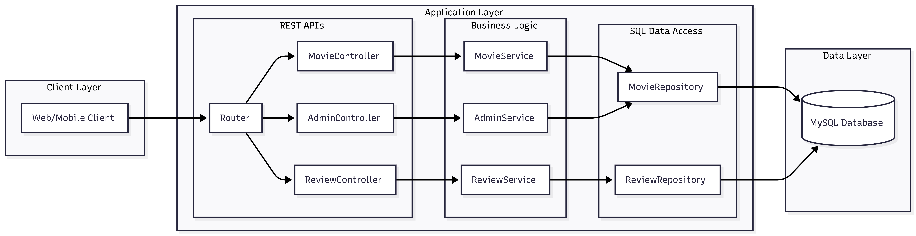
2.2 Component Responsibilities
- Controllers (*Controller): Handle HTTP requests, perform basic validation, and delegate business logic to services.
- Services (*Service): Contain the core business logic, transaction management, and orchestrate calls between repositories.
- Repositories (*Repository): Interface with the database using Spring Data JPA for CRUD operations and custom queries.
- Entities (Movie, Review): Map directly to database tables and define the object-relational model.
- Data Transfer Objects (DTOs - *Request, *Response): Define the contract for API inputs and outputs, decoupling the internal entity model from the external API.

3. Data Model & Database Design
3.1 Entity Relationship Diagram (ERD)
The system uses a relational model with a one-to-many relationship between Movie and Review.
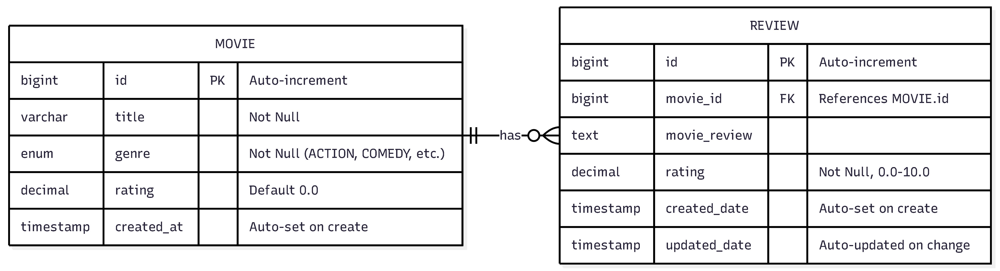
3.2 Table Specifications
Table: movie_table
Column Name | Data Type | Constraints | Description
Id | BIGINT | PRIMARY KEY, AUTO_INCREMENT | Unique identifier.
Title | VARCHAR(255) | NOT NULL | Title of the movie.
Genre | ENUM(...) | NOT NULL | Genre from predefined list.
Rating | DECIMAL(3,1) | DEFAULT 0.0 | Average rating (0.0 to 10.0).
created_at | TIMESTAMP | DEFAULT CURRENT_TIMESTAMP | Record creation timestamp.
Table: review_table
Column Name | Data Type | Constraints | Description
Id | BIGINT | PRIMARY KEY, AUTO_INCREMENT | Unique identifier.
movie_id | BIGINT | FOREIGN KEY, NOT NULL | References movie_table(id).
movie_review | TEXT |  | The textual review content.
rating | DECIMAL(3,1) | NOT NULL | Individual review score (0.0-10.0).
created_date | TIMESTAMP | DEFAULT CURRENT_TIMESTAMP | Review submission time.
updated_date | TIMESTAMP | DEFAULT CURRENT_TIMESTAMP ON UPDATE CURRENT_TIMESTAMP | Last edit time.

4. API Specification
4.1 Public Movie APIs
Endpoint | Method | Description | Query/Path Param | Request Body | Success Response
/movie | GET | Search for a single movie by its exact title. | title (String) | - | 200 OK (MovieResponse)
/movie | GET | Get the top 5 highest-rated movies for a genre. | genre (String) | - | 200 OK (List<MovieResponse>)
4.2 Review APIs
Endpoint | Method | Description | Query/Path Param | Request Body | Success Response
/review/add | POST | Submit a rating and review for a specific movie. | - | ReviewRequest (JSON) | 201 Created
/review/add/bulk | POST | Submit multiple reviews in one request. | - | List<ReviewRequest> | 201 Created
/review | GET | Retrieve a specific review by its ID. | Id (Long) | - | 200 OK (ReviewResponse)

4.3 Administrative Movie APIs
Endpoint | Method | Description | Query/Path Param | Request Body | Success Response
/admin/movie/add | POST | Add a new movie to the catalog. | - | MovieRequest (JSON) | 201 Created (MovieResponse)
/admin/movie/add/bulk | POST | Add multiple new movies to the catalog. | - | List<MovieRequest> | 201 Created (List<MovieResponse>)
/admin/movie/update/{id} | PUT | Update the title and/or genre of an existing movie. | id (Long) | MovieRequest (JSON) | 200 OK (MovieResponse)
/admin/movie/delete/{id} | DELETE | Remove a movie and its associated reviews from the catalog. | id (Long) | - | 204 No Content

4.4 Data Transfer Object (DTO) Examples
MovieRequest (POST/PUT /admin/movie/)
json
{
"title": "Inception",
"genre": "SCI_FI"
}
ReviewRequest (POST /review/add)
json
{
"movieReview": "A mind-bending masterpiece with incredible visuals.",
"rating": 9.5,
"movieId": 1
}
MovieResponse (GET /movie, GET /movie/genre)
json
{
"movie_id": 1,
"title": "Inception",
"genre": "SCI_FI",
"avg_rating": 8.7,
"reviews": [
{
"review_id": 101,
"review": "A mind-bending masterpiece...",
"rating": 9.5
}
]
}

5. Naming Conventions & Project Structure
5.1 Java Package Structure
com.reviews.movie_review
├── MovieReviewApplication.java # Main application class
├── controller/ # REST API endpoints
│ ├── AdminController.java
│ ├── MovieController.java
│ └── ReviewController.java
├── service/ # Business logic layer
│ ├── AdminService.java
│ ├── MovieService.java
│ └── ReviewService.java
├── repository/ # Data access layer (Spring Data JPA)
│ ├── MovieRepository.java
│ └── ReviewRepository.java
├── domain/ # JPA Entity classes
│ ├── Movie.java
│ ├── Review.java
│ └── Genre.java # Enum
└── service/
├── request/ # Incoming API request DTOs
│ ├── MovieRequest.java
│ └── ReviewRequest.java
└── response/ # Outgoing API response DTOs
├── MovieResponse.java
└── ReviewResponse.java

